**Lauren Pelayo, Alex Lundin, Thomas Lindholm**

PHYS 2125.104.603

Sep. 7, 2015

**Lab 1: Basic Motion and Graphing**

**Table of Contents**

**1.) Cover Page**

**2.) Data**

**3.) Calculations**

**4.) Analysis Questions**

**-Plots**

**-Answers**

Lab 1: Basic Motion and Graphing

TA: Matthew Fong

Lab Section: #603

September 7, 2015

Lauren Pelayo (data recorder)

Alex Lundin (timer)

Thomas Lindholm (weight let go-er)

2.) Data:

|  |  |  |  |  |
| --- | --- | --- | --- | --- |
| $$Δx (m)$$ | $$t_{1}(s)$$ | $$t_{2}(s)$$ | $$t_{3}(s)$$ | $$t_{avg}(s)$$ |
| 0.3 | 2.64 | 2.42 | 2.31 | 2.39 |
| 0.4 | 2.98 | 3.03 | 2.46 | 2.99 |
| 0.5 | 3.35 | 3.04 | 3.45 | 3.28 |
| 0.6 | 3.68 | 3.59 | 3.65 | 3.64 |
| 0.7 | 3.90 | 4.01 | 3.86 | 3.92 |
| 0.8 | 4.12 | 4.09 | 4.20 | 4.14 |

Table 1: data table for average time recorded in three trials with two tiles

|  |  |
| --- | --- |
| $${log(position)}_{}$$ | $${log(time}_{avg})$$ |
| -0.52 | 0.38 |
| -0.40 | 0.48 |
| -0.30 | 0.52 |
| -0.22 | 0.56 |
| -0.15 | 0.59 |
| -0.10 | 0.62 |

Table 2: table of log of position and log of average time with two tiles

|  |  |
| --- | --- |
| $${ln(position)}_{}$$ | $${time}_{avg}$$ |
| -1.20 | 2.39 |
| -0.92 | 2.99 |
| -0.69 | 3.28 |
| -0.51 | 3.64 |
| -0.36 | 3.92 |
| -0.22 | 4.14 |

Table 3: table of natural log of position and average time with two tiles

|  |  |  |  |  |
| --- | --- | --- | --- | --- |
| $$Δx (m)$$ | $$t_{1 }(s)$$ | $$t_{2 }(s)$$ | $$t_{3 }(s)$$ | $$t_{avg }(s)$$ |
| 0.30 | 1.80 | 1.73 | 1.95 | 1.83 |
| 0.40 | 2.30 | 2.16 | 2.29 | 2.25 |
| 0.50 | 2.45 | 2.50 | 2.50 | 2.48 |
| 0.60 | 2.76 | 2.73 | 2.78 | 2.76 |
| 0.70 | 3.15 | 2.86 | 2.92 | 2.98 |
| 0.80 | 3.11 | 3.18 | 3.28 | 3.19 |

Table 4: data table for average time recorded in three trials with three tiles

|  |  |
| --- | --- |
| $${log(position)}_{}$$ | $${log(time}_{avg})$$ |
| -0.52 | 0.26 |
| -0.40 | 0.35 |
| -0.32 | 0.39 |
| -0.22 | 0.44 |
| -0.15 | 0.47 |
| -0.10 | 0.50 |

Table 5: table of log position and log average time with three tiles

|  |  |
| --- | --- |
| $${ln(position)}_{}$$ | $${time}_{avg}$$ |
| -1.20 | 1.83 |
| -0.92 | 2.25 |
| -0.69 | 2.48 |
| -0.51 | 2.76 |
| -0.36 | 2.98 |
| -0.22 | 3.19 |

Table 6: table of natural log and average time with three tiles

3.) Calculations:

Sample calculations from trial 1 with two tiles:

$t_{avg}=$ $\frac{t_{1}+t_{2}+t_{3}}{\# of trials}$

$t_{avg}=$ $\frac{\left(2.64+2.42+2.31\right)s}{3}$

$t_{avg}=$ $\frac{7.37s}{3}$

$t_{avg}=$ 2.39 $s_{}$

$log⁡(pos)=$ $log(0.3m)$

$log⁡(pos)=$ $-0.52m$

$log⁡(t_{avg})=$ $log(\frac{t_{1}+t_{2}+t_{3}}{\# of trials})$

$log⁡(t_{avg})=$ $log( \frac{(2.64+2.42+2.31)s}{3})$

$log⁡(t_{avg})=$ $log(2.39 s_{})$

$log⁡(t_{avg})=$ $.38s$

$ln⁡(pos)=$ $ln(0.3m)$

$ln⁡(pos)=$ $-1.20m$

4.) Analysis:

**(Q5.1 Plots)**

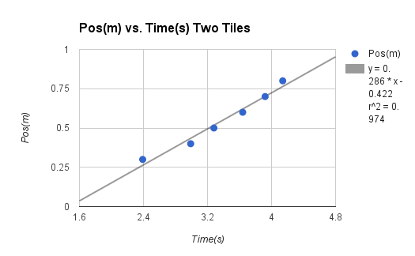

Plot 1: position vs. average time with two tiles data taken from table 1

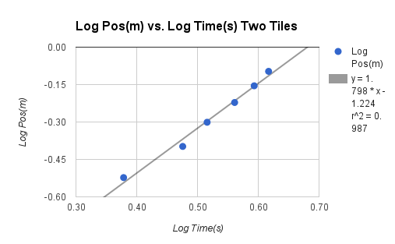

Plot 2: log of position vs. log of time with two tiles data taken from table 2

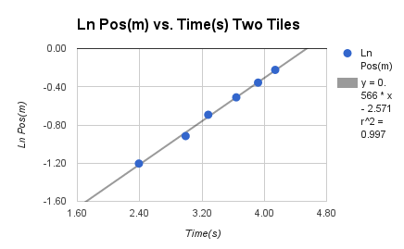

Plot 3: natural log of position vs. time with two tiles data taken from table 3

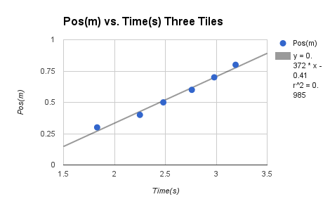

Plot 4: position vs. average time with three tiles data taken from table 4

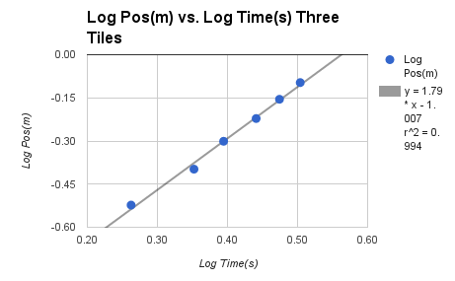

Plot 5: log of position vs. log of time with three tiles data taken from table 5

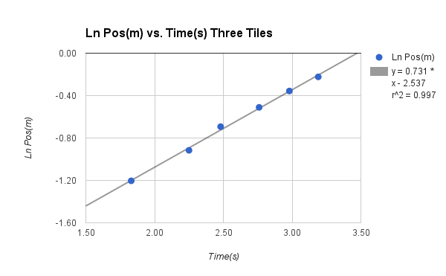

Plot 6: natural log of position vs. average time with three tiles data taken from table 6

**(Q5.1 Answer)**

This is an explanation of how we calculated our experimental equations based on the above plots. Plots 1-3 contained information from our two tile setup, while plots 4-6 contained information from our three tile setup. First, we found the plot in each set with the largest R value. Next, we referred to the “PHYS 2125-Graphing Skills Handout.pdf” and converted the trend line back into a linear equation if necessary. For the 2 tiles data set, our highest R value was a power equation. So we had to convert it back into a linear equation. For the 3 tile data set, our highest R value was already a linear equation. These are the two experimental equations that best describe each separate data set collected in Plots 1-6:

2 Tiles:

Type: Power

Name: Log Pos(m) vs. Log Time(s) -- Plot 2

R^2 value = .987

Linearization Equation: y = mt x + bt

y = 1.798 x + (-1.224)

mt = m = 1.798

bt = -1.224

b = 10^( -1.224) = .0597

Experimental Equation: y = b (x^m)

y = .0597 (x ^(1.798))

3 Tiles:

Type: Linear

Name: Pos(m) vs. Time(s) -- Plot 4

R^2 value = .985

Linearization Equation: y = .372 x + (-.041)

Experimental Equation: y = .372 x + (-.041)

**(Q5.2 Plots)**

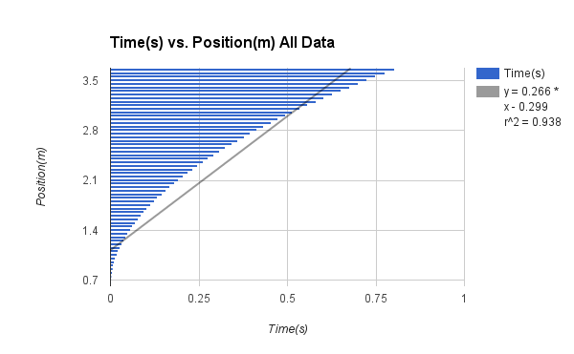

Plot 7: time vs. position using all data from 4.2.3

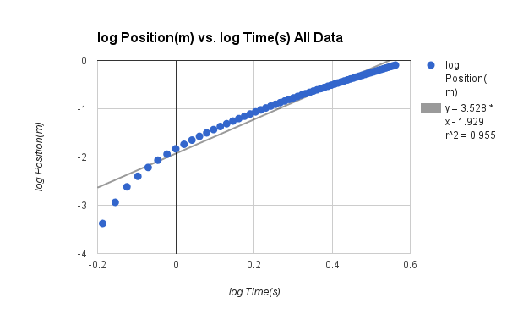

Plot 8: log of position and log of time using all data from 4.2.3

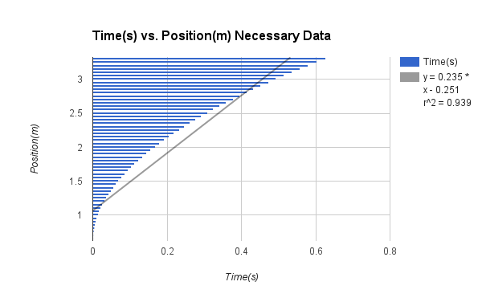

Plot 9: time vs. position only using necessary data from 4.2.3

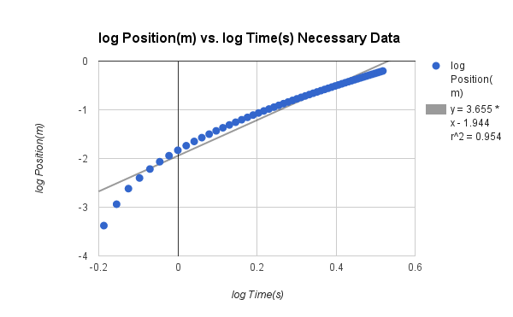

Plot 10: log of position vs. log of time only using necessary data from 4.2.3

**(Q5.2.a)** Originally when we did the experiment and had to save the data on an excel spreadsheet, we only saved what we thought was necessary. We did not save all the data so that is why the plots look almost the exact same. We left off the end of the original data because the weight had hit the ground and things were flying everywhere so we decided not to count that.

**(Q5.2.b)** The log graph with just the necessary data has a better trendline fit.

**(Q.5.2.c)** The slopes are similar to the function f(x) = $\sqrt{x}$ I would expect the slopes to be positive because the tool holding the weights was accelerating as it was going down the track.

**(Q5.2.d)** We think that based on our experiment and the data that we collected, that we confirmed theory.

**(Q.5.2.e)** The timer will not get the precise time that the tool holding the weights meets the end of the track. Some of the recording of the data was miscommunicated and at times the person recording the data on the computer will start recording before the tool goes down the track. At times, the tool moved backwards, so the data recording it with having a negative position.

**(Q.3 Plots)**

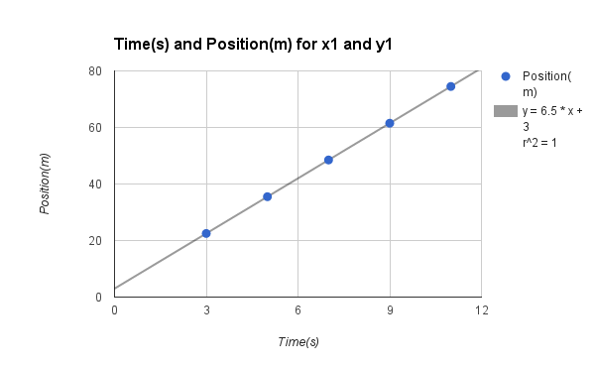

Plot 11: graph for set x1 and y1 with a linear equation

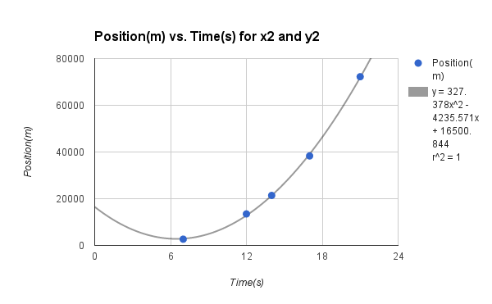

Plot 12: graph for set x2 and y2 with a power equation

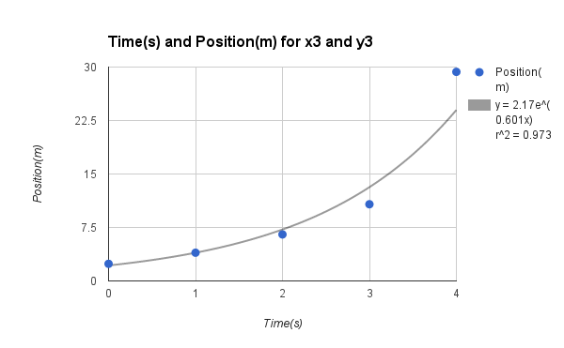

Plot 13: graph for set x3 and y3 using an exponential equation